DBMS Lab Assignment 2

Neeti Kurulkar

Design and develop SQL statements which demonstrate the use of SQL object such as Table, View, Index, Sequence, Synonym and Various Constraints etc

Queries:

1. Create DEPT and EMP tables with given constraints

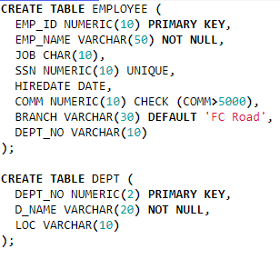

1. Insert records into table

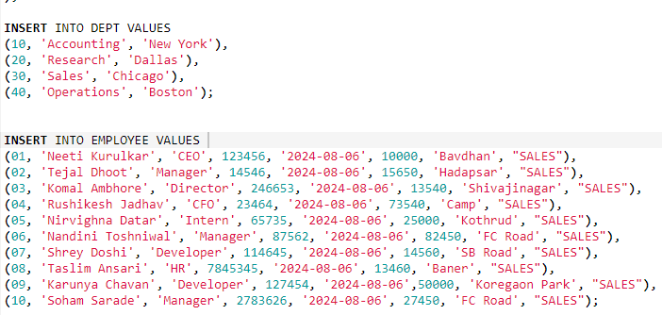

1. Alter table EMP to add new column Salary



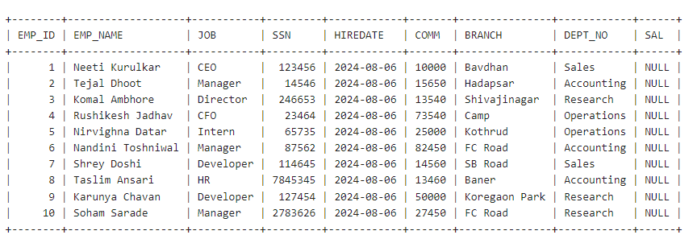

1. Create Unique Index on SSN field of the EMP table.



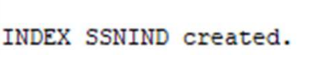

1. Create a View on EMP table

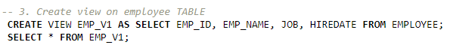

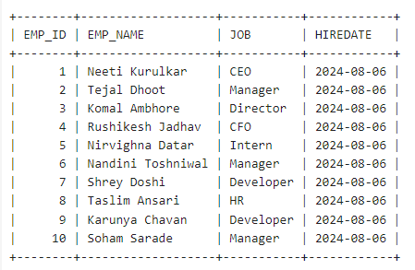

1. Create a SEQUENCE by the name SEQ, which will generate numbers from 1 to 25 in ascending order with an interval of 1. The sequence must restart from 1 after generating number 25. Insert the SEQ values in column code.

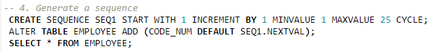

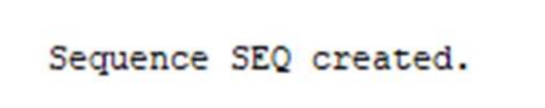

1. Create Synonym for table DEPT.



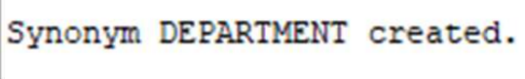

1. Drop Primary Key constraint on DEPT table.



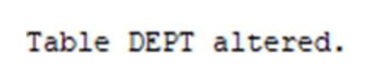

1. For DEPT table create Composite Primary Key as DEPTNO and DNAME



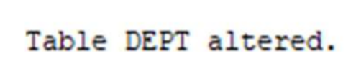

1. Modify size of field BRANCH in table EMP

